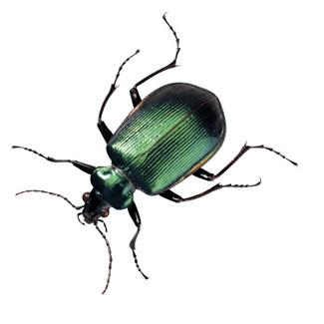
Bug Collection Guidelines
for Fourth Graders
Due Date: Friday, September 21, 2018
- Each student must have 10 different bugs for display.
(A sample of a molting shell or a cocoon may be counted as a bug.)
- The bugs must be labeled by their common name, the place where it was found by the student, and when it was found by the student.
Sample Label: Grasshopper
Grandma’s house, Anderson, IN
September 2018
- Each bug must be neatly attached by glue or a straight pin.
- Boards can be made of corrugated cardboard or foam board. (Any neat, sturdy substance may be substituted if necessary.)
- The board should be attractive (creativity is encouraged) and completed by the students with parental supervision.
Please remember that the final product should reflect the student’s performance on the assignment.

- Make sure the display board is neatly labeled on the bottom left of

the board with the following:

Student’s Name Joe Ring

Grade and Year 4th Grade – 2018

Teacher’s Name Mrs. Schieber

School’s Name Indiana Christian Academy

