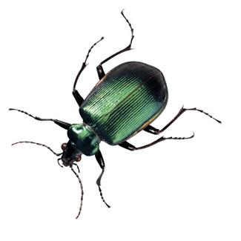
Bug Collection Project Guidelines
Due Date: Wednesday, Sept. 27th
- Each student must have 10 different bugs for display.
(A sample of a molting shell or a cocoon may be counted as a bug.)
- The bugs must be labeled by their common name, the place where it was found by the student, and when it was found by the student.
Sample Label: Grasshopper
Grandma’s house, Anderson, IN
September 2017
- Each bug must be attached by glue or a straight pin.
- Boards can be made of corrugated cardboard or foam board. (Any neat, sturdy substance may be substituted if necessary.)
- The board should be attractive (creativity is encouraged) and completed by the students with parental supervision.
Please remember that the final product should reflect the student’s performance on the assignment.
- Make sure the display board is labeled with the following:
Student’s Name Joe Smith
Grade and Year 4th grade – 2017
Teacher’s Name Mrs. Schieber
School’s Name Indiana Christian Academy
Examples of Bug Projects
