8th U.S. History
Instructor: Mr. Lingle
- Phone: 920-342-5368
- Email: stevelingle@gmail.com
- Website: http://indianachristianacademy.org/mr-lingle-class-page/
Textbook:
- United States History, 4th Ed.
Course Description:
The goal of United States History is to understand and appreciate America’s great history compared to the rest of the world. To accomplish the goal of U.S. History, students will learn, study, and research different topics to better understand how they have been impacted our nation’s history.
Course Objectives:
- Students should understand how the United States has developed as a nation.
- Introduce students to ideals/ideas that have developed historically into the American Tradition.
- Students will be able to highlight the main points of United States history.
Classroom Supplies:
- Blue or black pens (pencils acceptable)
- Red pens
- Notebook paper and notebook/binder
Grading:
Students will have the following breakdown of their U.S. History grade:
- 15% Quizzes
  - Usually one per chapter
  - Will occur in the middle of the chapter
- 25% Projects
  - Book Reports
    - One due each quarter
    - One hundred pages of reading required per quarter
    - Books must be preapproved by Mr. LIngle
    - Books must be focused on U.S. History and cannot be historical fiction
    - Book Reports due on Friday, Sept. 30th and Tuesday, Nov. 29th
  - Additional projects will be assigned throughout the year
- 30% Homework
  - Assigned daily in many formats ex. reading, questions, research, etc.
  - No red pen!
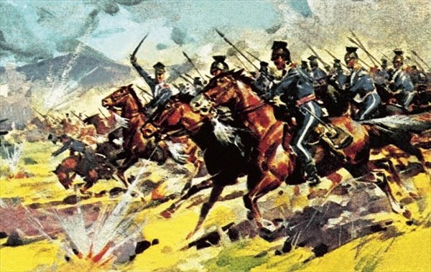
  - Homework due at beginning of class
  - Homework may be turned in one day late for 75% credit
  - One homework score will be dropped
- 30% Tests
  - Normally one per chapter
Absences:
If students miss any days due to an excused absence the student has the same number of days to make it up. It is the student’s responsibility to find out the work missed and then to make it up.
Ethics:
Any attempt at plagiarism or cheating will not be tolerated and will be given an automatic zero. Cheating is the attempt to take another person’s work and to make it your own without you doing any effort at doing the work.
General Classroom Policies:
- Students may talk when given permission by Mr. Lingle.
- Students have the privilege of being in the classroom and being prepared when the bell rings.
- Students get to work on History homework only unless given permission. If found it will be taken.
- Be respectful to Mr. Lingle, your peers, and to property.
- Smartwatches must not be on wrists during quizzes or tests.
- All student handbook rules will be enforced.
- Catch 22- Mr. Lingle can add any rules or procedures throughout the year.
Consequences
- In the unlikely event of disobedience, disrespect, or disruption in class, discipline may include – but not limited to – the following in any sequence the teacher deems appropriate. Warning (verbal or non-verbal), reprimand, after class, call/email to parents, detentions, demerits, office referral, or expulsion from class (temporary or permanent).

