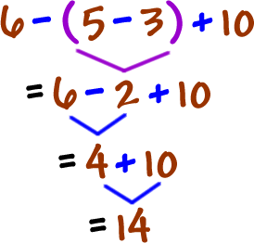
Pre-Algebra
Instructor: Mr. Lingle
- Phone: 920-342-5368
- Email: stevelingle@gmail.com
- Website: http://indianachristianacademy.org/mr-lingle-class-page/
Textbook:
- Pre-Algebra, 2nd ed. Bob Jones
Course Description:
- This course is designed to ready the student for Algebra. Topics include the real number system; adding, subtracting, multiplying and dividing real numbers; common factors and multiples, area, volume, word problems, ratios, and proportions, and writing and solving equations.
Course Objectives:
At the completion of this course, I will expect that the learner can:
- Feel comfortable adding, subtracting, multiplying and dividing real numbers.
- Utilize your mathematics skills to learn Prealgebra concepts and techniques.
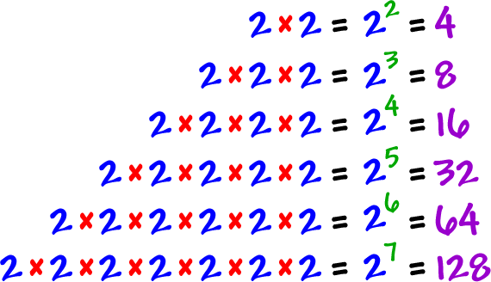
- Use graphing technology as a tool to explore and gain further understanding in Prealgebra.
- Understand the nature of problem solving.
- Prepare for other courses in mathematics.
Classroom Supplies:
The following items should be brought daily.
- Textbook
- Pencils
  - Absolutely no pens
- Notebook paper
- Three-ring binder

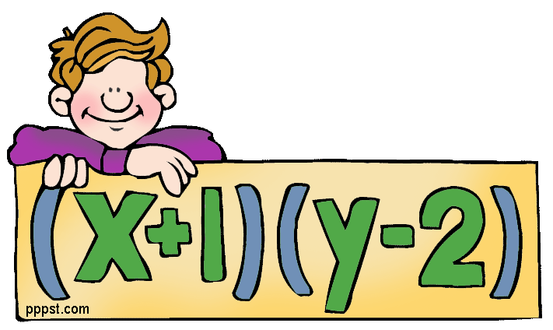
Grading:
Students will have the following breakdown of their Prealgebra grade:
- 35% Homework
  - Homework is assigned daily and is usually 15-20 problems
  - Students may turn in homework corrections for 50% of the original credit on the next day
    - Corrections must be done on a new sheet of paper, stapled to original lesson
  - Students must show their work for full credit
  - Homework can be turned in one day late for 75% credit, any later and it will be a zero.
    - Homework considered late if not turned in at beginning of class.
  - Homework is not accepted if done in pen
- 30% Tests (usually given every eight lessons)
- 10% Notebooks
  - Notes graded upon the previous nights video
- 10% Video Completion (Super important for you to achieve success!)
  - Any night a video is required, it is an all or nothing grade
- 10% Final Exam
  - Test over the semester of math lessons
- 5% Speed Drills
  - Done bi-weekly after several practice attempts
Absences:
- If students miss any days due to an excused absence the student has the same number of days to make it up. It is the student’s responsibility to find out the work missed and then to make it up.
Ethics:
- Any attempt at plagiarism or cheating will not be tolerated and will be given an automatic zero.

General Classroom Policies:
- Students may talk when given permission by Mr. Lingle.
- Students have the privilege of being in the classroom and being prepared when the bell rings.
- Students get to work on Math homework only unless given permission. If found it will be taken.
- Be respectful to Mr. Lingle, your peers, and to property.
- Smartwatches must not be on wrists during tests.
- All student handbook rules will be enforced.
- Catch 22- Mr. Lingle can add any rules or procedures throughout the year.
Consequences
- In the unlikely event of disobedience, disrespect, or disruption in class, discipline may include – but not limited to – the following in any sequence the teacher deems appropriate. Warning (verbal or non-verbal), reprimand, after class, call/email to parents, detentions, demerits, office referral, or expulsion from class (temporary or permanent).

How to create an account on Schoology:
- Go to www. schoology.com
- Go to signup in the top right corner
- Click on student
- Type in your name, an email account, password for the email account, and birthday
- Type in the access code for Pre-Algebra class
- 9C23H-8NQTC (exactly as it appears)
- You will need final confirmation by Mr. Lingle and then you will be able to access the class

